Game Design Document

Fill up the following document

1. Write the title of your project.

HEROSHIVA in Jungle

1. What is the goal of the game?

Collect the coins and diamond while running through Jungle

1. Write a brief story of your game.

The boy/character has to run through the Jungle. On the way he will

Be collecting points and also has to dodge the obstacles.

1. Which are the playing characters of this game?

* Playing characters are the ones who respond to the user based on the input from the user.
* Cars, monkeys, dinos, wizards, etc., are the playing characters in the game.

|  |  |  |
| --- | --- | --- |
| Number | Character Name | What can this character do? |
| 1 | HEROSHIVA | Jump,run |
| 2 |  |  |
| 3 |  |  |
| 4 |  |  |
| 5 |  |  |
| 6 |  |  |
| 7 |  |  |
| 8 |  |  |

1. Which are the Non-Playing Characters of this game?

* Non-Playing characters are the ones that don't have an action or behavior when the user interacts with the game.
* Hurdles, stones, bananas, coins, etc., are non-playing characters in the game.

|  |  |  |
| --- | --- | --- |
| Number | Character Name | What can this character do? |
| 1 | SNAKE |  |
| 2 | STONE |  |
| 3 | Other Obstacles |  |
| 4 |  |  |
| 5 |  |  |
| 6 |  |  |
| 7 |  |  |
| 8 |  |  |

Draw your imagination of this game. What does this game look like?

* Draw the game either on your computer or on paper.
* Add images of the game scenes to show each of the playing and non-playing characters at least once.

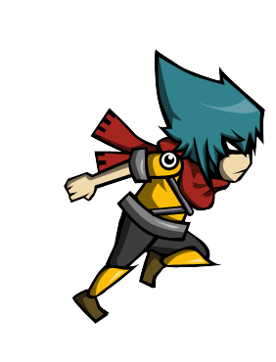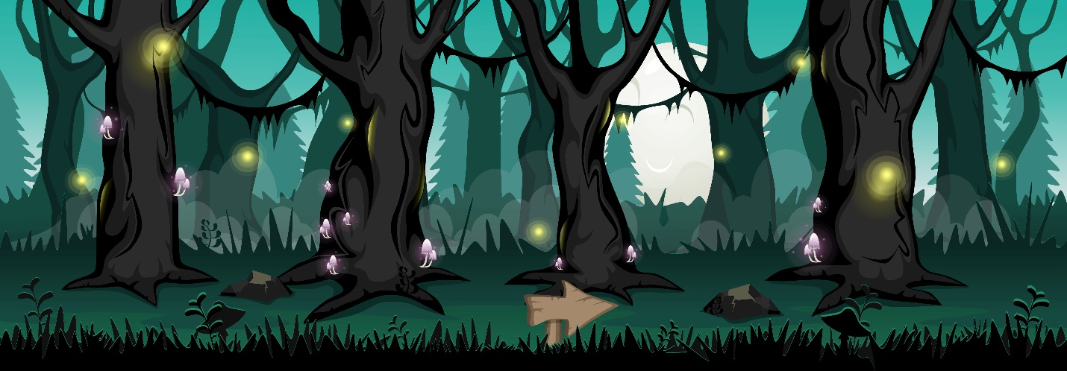

How do you plan to make your game engaging?

By sapawning more obstacles and making the player collect treasure.